Tri-Basin Irrigator

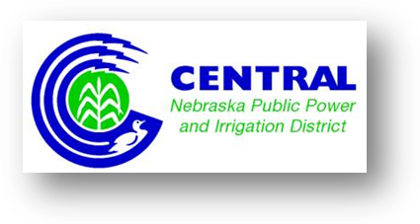
CNPPID Notes

Title:

Tri-Basin NRD News 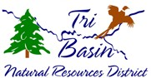

Consider Planting Conservation Trees:
It is not too early to think about planting conservation trees next spring! Windbreaks and shelterbelts provide many benefits, including reducing soil erosion along field boundaries. We provide tree planting services for your windbreak, as well as trees in bundles of 25 you plant yourself. Contact us or your local NRCS office to determine the number and species of trees or shrubs you would like to plant. Order forms for hand plant trees will be available in mid-October in our office or on our website, www.tribasinnrd.org. 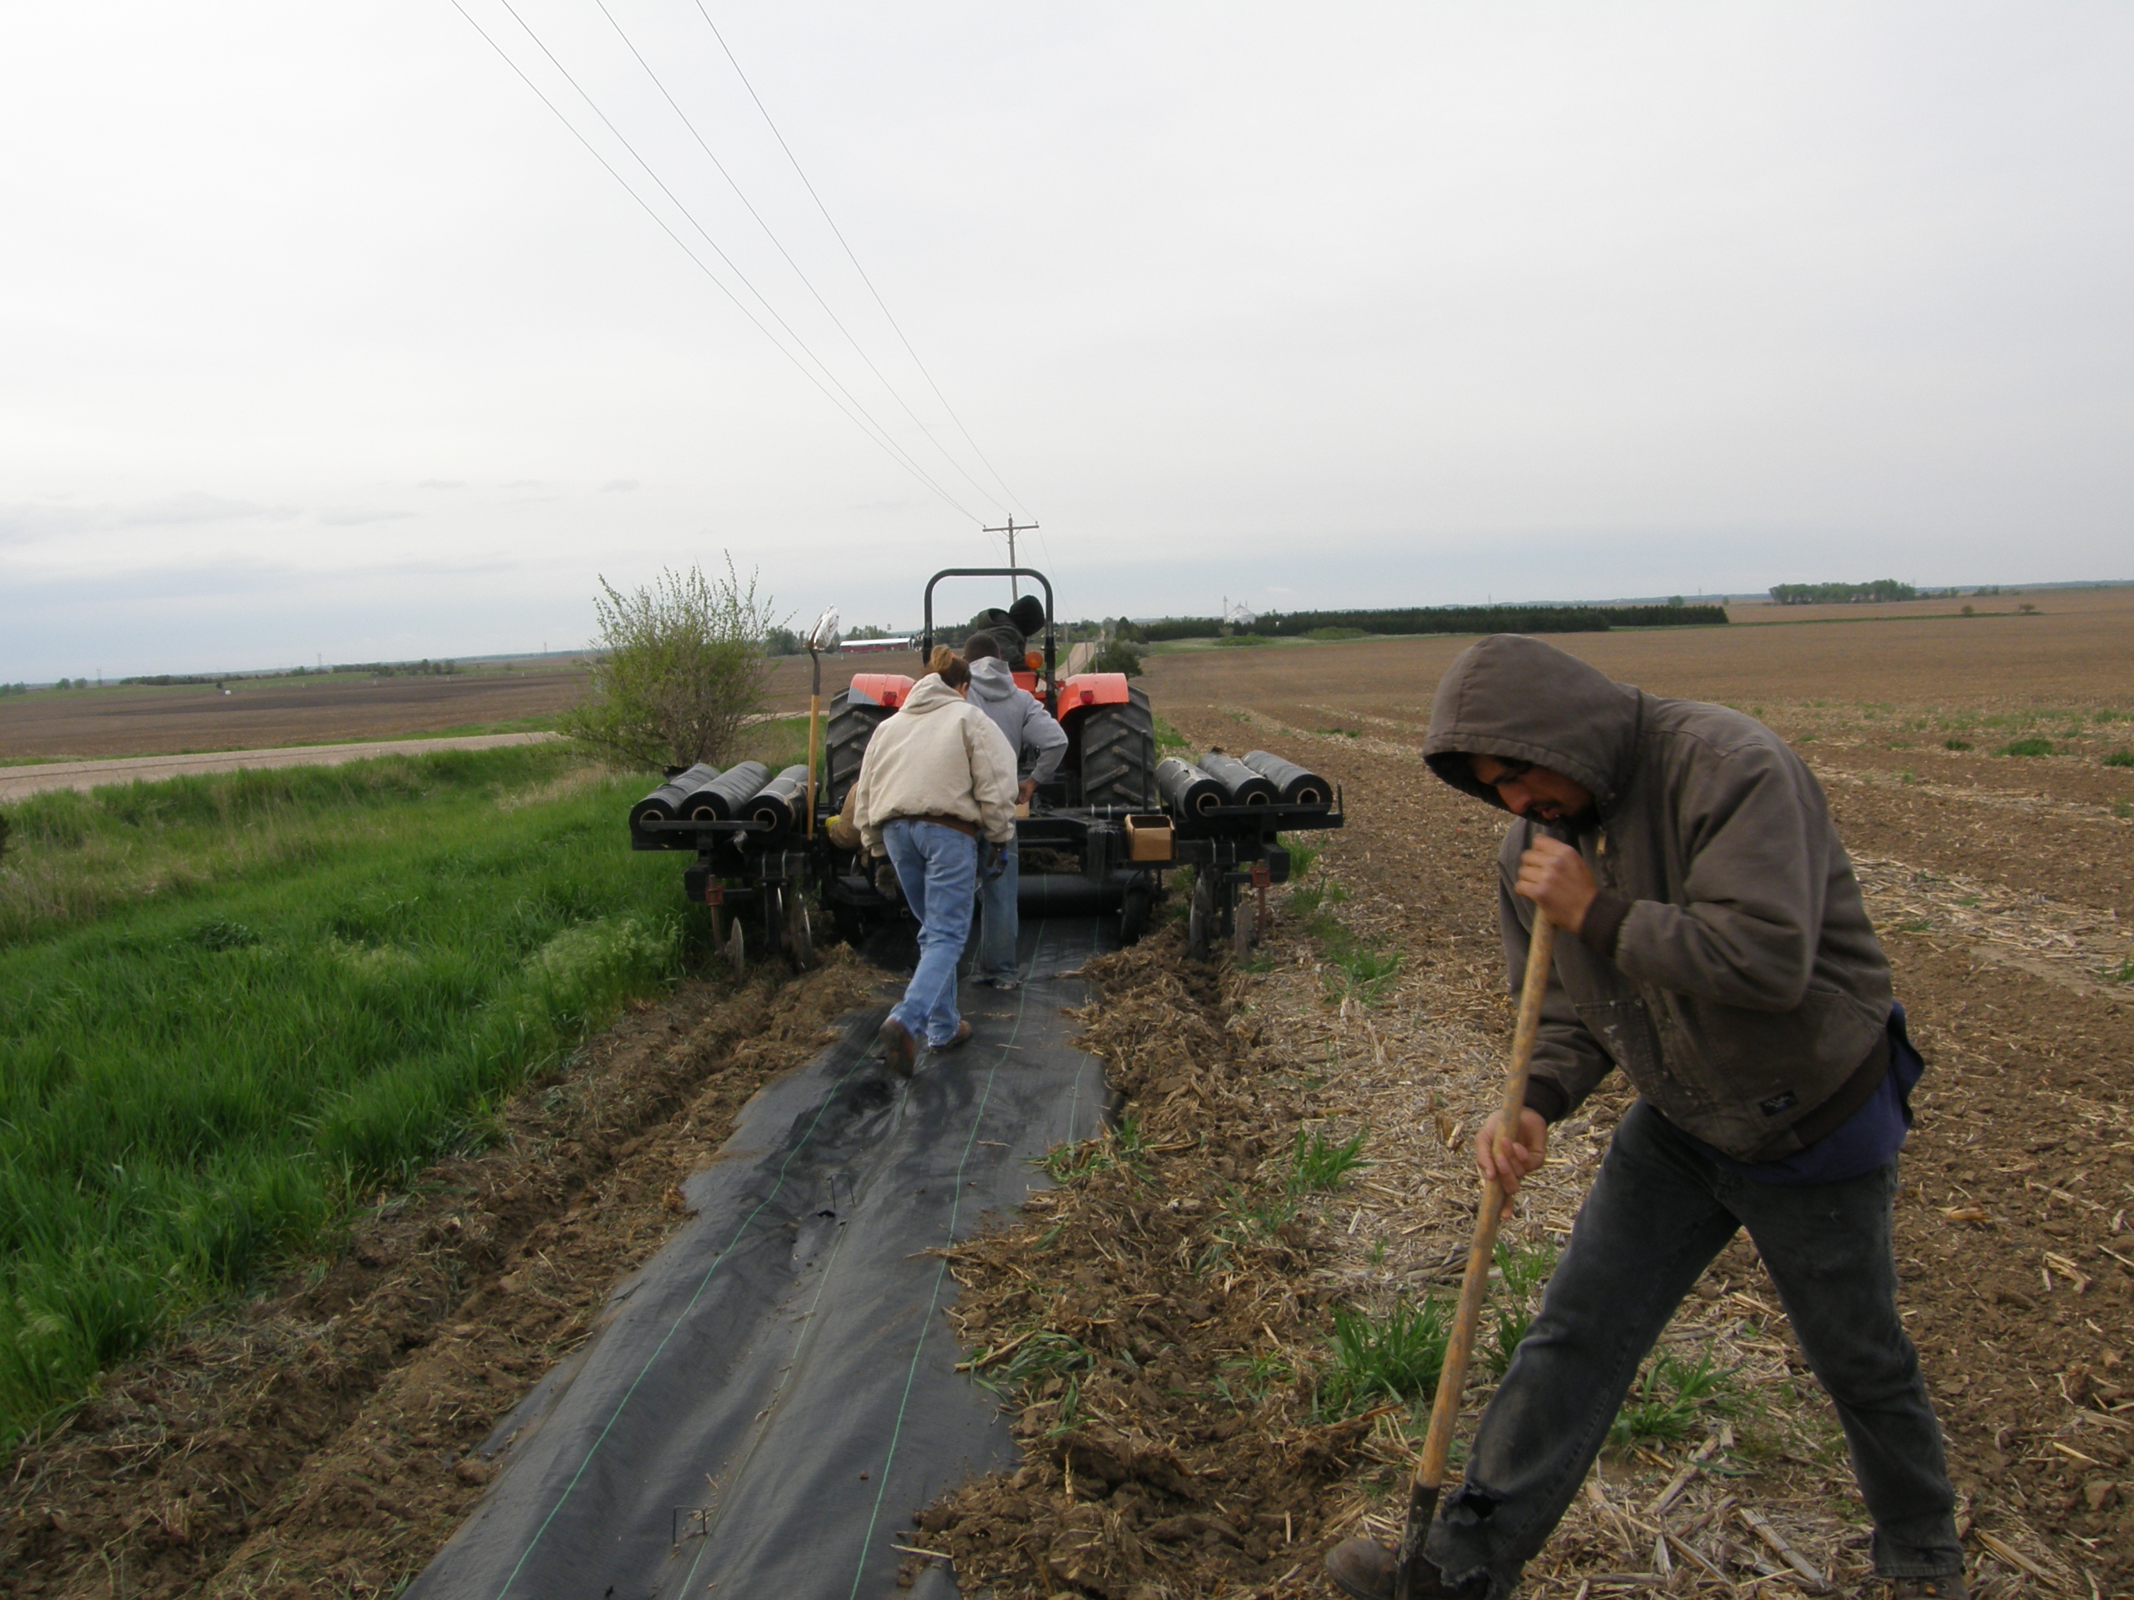

UNL Extension Extras

Title:

.

