Tri-Basin Irrigator


CNPPID Notes

Title:

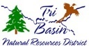
Tri-Basin NRD News

Assistance to Treat Infestation
Invasive Phragmites australis, also known as common reed, is a highly aggressive perennial plant that thrives in wet environments such as rivers, ponds, creeks, ravines, and road ditches. It spreads rapidly through both seeds and rhizomes, allowing it to expand its presence significantly within a single season. Unfortunately, it offers no forage value for livestock or wildlife, making it a problematic species.
Landowners must control phragmites on their property as it is on Nebraska’s Noxious Weed list. The Twin Valley Weed Management Area (TVWMA) and Platte Valley Weed Management Area (PVWMA) have worked diligently over the past several years to combat phragmites along river channels. The TVWMA and PVWMA, with grant funding from the Nebraska Environmental Trust, can aid landowners in treating phragmites.
If you have phragmites on your property, contact your County Weed Superintendent to see if you are eligible to have it sprayed free of charge.
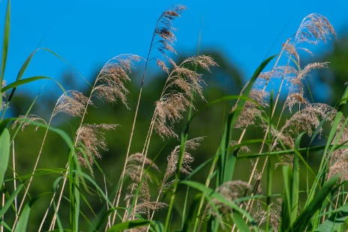
Gosper:
Marty Craig-
308-324-3771,
Phelps:
Jim Clampitt-
308-991-0139,
Kearney:
Joe Anderson-
308-832-2854


UNL Extension Extras

Title:

.

